程序代码：

1、#include <iostream>

using namespace std;

class Coordinate {

public:

Coordinate()

{

times = 2;

cout << "Coordinate construction1 called!" << endl;

}

Coordinate(int times1)

{

times = times1;

cout << "Coordinate construction2 called!" << endl;

}

~Coordinate()

{

cout << "Coordinate destruction called!" << endl;

}

void InputCoord()

{

for (int i = 0; i < times; i++)

{

cout << "Please Input x:" << endl;

cin >> Coord[i][1];

cout << "Please Input y:" << endl;

cin >> Coord[i][2];

}

}

void ShowCoord()

{

cout << "The coord is:" << endl;

for (int i = 0; i < times; i++)

{

cout << "(" << Coord[i][1] << "," << Coord[i][2] << ")" << endl;

}

}

void ShowAvgCoord()

{

float avgx = 0;

float avgy = 0;

for (int i = 0; i < times; i++)

{

avgx = avgx + Coord[i][1];

avgy = avgy + Coord[i][2];

}

avgx = avgx / times;

avgy = avgy / times;

cout << "The AVG coord is:" << endl;

cout << "(" << avgx << "," << avgy << ")" << endl;

}

private:

float Coord[100][100];

int times;

};

int main()

{

Coordinate x;

x.InputCoord();

x.ShowCoord();

x.ShowAvgCoord();

y.InputCoord();

y.ShowCoord();

y.ShowAvgCoord();

system("pause");

return 0;

}

2、#include<iostream>

#include<string>

using namespace std;

class Score {

public:

Score()

{

times = 2;

}

Score(int times1)

{

times = times1;

}

void InputNameAndScore()

{

for (int i = 0; i < times; i++)

{

cout << "请输入学生姓名:" << endl;

cin >> Name[i];

cout << "请输入科目A成绩:" << endl;

cin >> SScore[i][1];

cout << "请输入科目B成绩:" << endl;

cin >> SScore[i][2];

cout << "请输入科目C成绩:" << endl;

cin >> SScore[i][3];

}

}

void ShowNameAndScore()

{

for (int i = 0; i < times; i++)

{

cout << "姓名: " << Name[i] << " 科目A成绩: " << SScore[i][1] << " 科目B成绩 " << SScore[i][2] << " 科目C成绩: " << SScore[i][3] << endl;

}

}

void ShowStdentAvgScore(int Sid)

{

float avg = 0;

avg = (SScore[Sid][1] + SScore[Sid][2] + SScore[Sid][3]) / 3;

cout << "姓名: " << Name[Sid] << " 平均成绩: " << avg << endl;

}

void ShowClassAvgScore(string ClassName)

{

int Cid;

float avg = 0;

if (ClassName == "A") Cid = 1;

if (ClassName == "B") Cid = 2;

if (ClassName == "C") Cid = 3;

for (int i = 0; i < times; i++)

{

avg = avg + SScore[i][Cid];

}

avg = avg / times;

cout << "课程名称: " << ClassName << "平均成绩: " << avg << endl;

}

void OrderScore(string ClassName)

{

int Cid;

if (ClassName == "A") Cid = 1;

if (ClassName == "B") Cid = 2;

if (ClassName == "C") Cid = 3;

for (int i = 0; i < times; i++)

{

SScore1[i] = SScore[i][Cid];

}

for (int i = 0; i < times; i++)

{

Name1[i] = Name[i];

}

for (int i = 1; i < times; i++)

{

if (SScore1[i] > SScore1[i - 1])

{

float temp = SScore1[i - 1];

SScore1[i - 1] = SScore1[i];

SScore1[i] = temp;

string temp1;

temp1 = Name1[i - 1];

Name1[i - 1] = Name1[i];

Name1[i] = temp1;

}

}

cout << "课程名称: " << ClassName << endl;

for (int i = 0; i < times; i++)

{

cout << "姓名: " << Name1[i] << " 成绩: " << SScore1[i] << endl;

}

}

private:

float SScore[100][3], SScore1[100];

string Name[100], Name1[100];

int times;

};

int main()

{

Score x;

x.InputNameAndScore();

x.ShowNameAndScore();

x.ShowStdentAvgScore(1);

x.ShowClassAvgScore("A");

x.OrderScore("B");

system("pause");

return 0;

}

运行结果：

1、

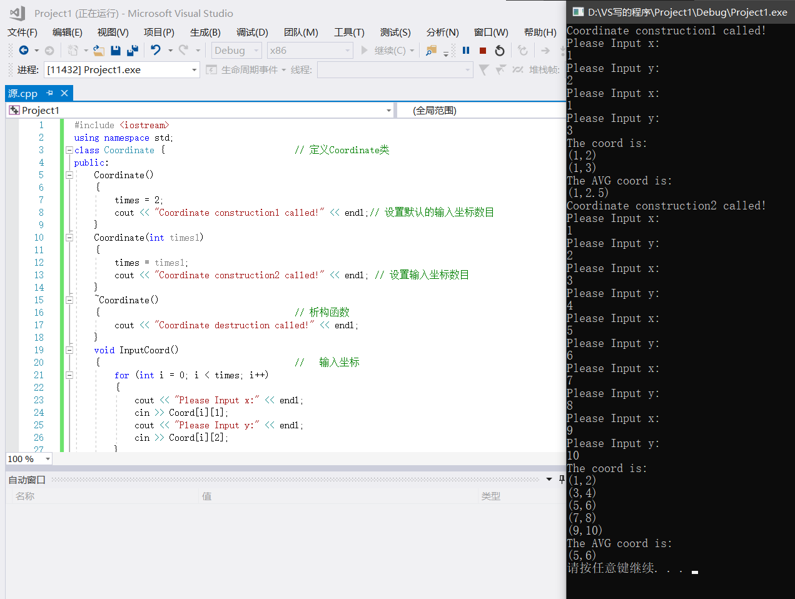2、

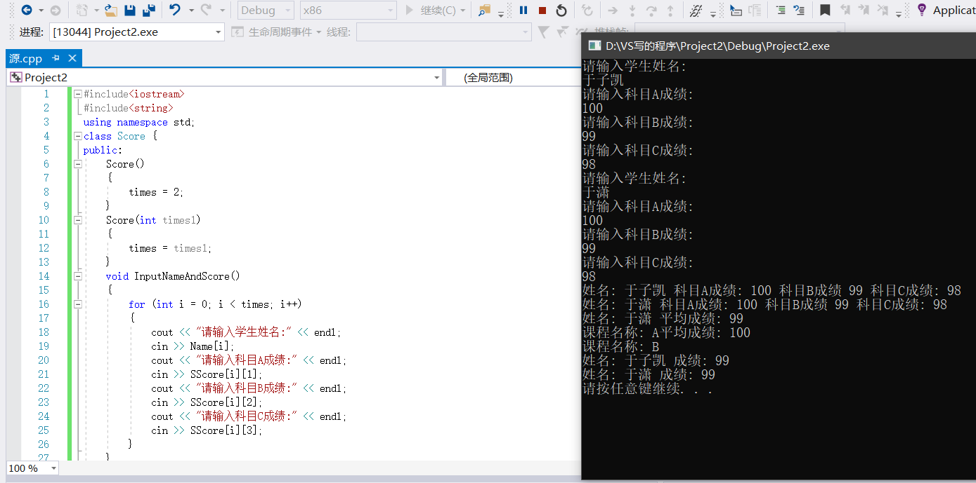感想心得：

构造函数和析构函数的使用是C语言中没有的，有些难理解，前者主要用来分配储存空间和数据初始化。后者则是释放储存空间。